|  |
| --- |
| Void oxygen Studios |
| Space Shooter |
| **COMP304 Assignment1** |
| Version # 0.20  All work Copyright © 2015 by XX Games.  All rights reserved. |
| **Brahmadut Ramkissoon 300500046** |
|  |

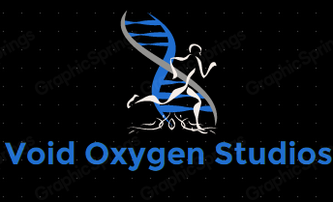

|  |
| --- |
| Oct 04th 2015 |

Contents

I. Version History 3

II. Game Overview 4

III. Game Play Mechanics 4

*IV.* Camera 4

V. Controls 4

VI. Saving and Loading 4

VII. Interface Sketch 5

VIII. Menu and Screen Descriptions 7

IX. Game World 10

X. Levels 10

XI. Characters 10

XII. Enemies 10

XIII. Weapons 10

XIV. Items 10

XV. Abilities 10

XVI. Vehicles 10

XVII. 10

XVIII. Script 10

XIX. Scoring 11

XX. Puzzles/Mini-games 11

XXI. Bonuses 11

XXII. Cheat Codes 11

XXIV. Story Index 11

XXV. Art / Multimedia Index 11

XXVI. Design Notes 12

XXVII. Future Features 12

1. Version History

# INSERT GITHUB LINK HERE

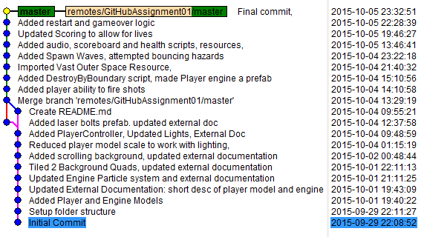

1. Game Overview

*Your ship has entered an asteroid field being affected by a nearby planet.*

*Defeat several waves of enemy alien ships and other obstacles*

1. Game Play Mechanics

*Survive the asteroid field*

1. Camera

*Orthographic view – top down over the player*

1. Controls

*Keyboard keys – W, A, S, D*

1. Saving and Loading

*Press play to start, no save feature yet.*

1. Interface Sketch

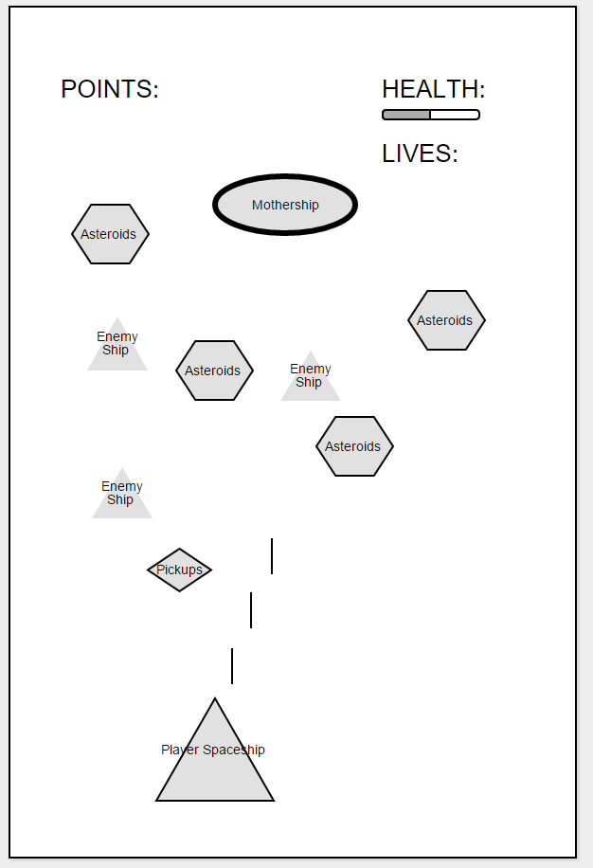

1. Menu and Screen Descriptions

*A simple menu will appear after the game is over.*

*The player will press ‘R’ to Restart the game. See below the 3 screenshots of the game at Start, During and End.*

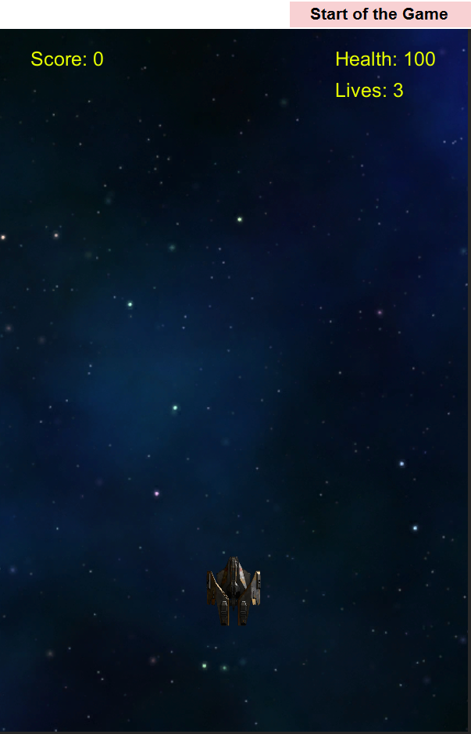

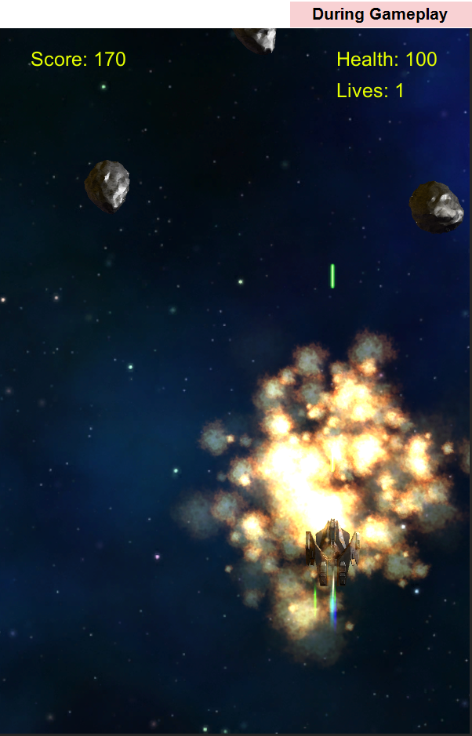

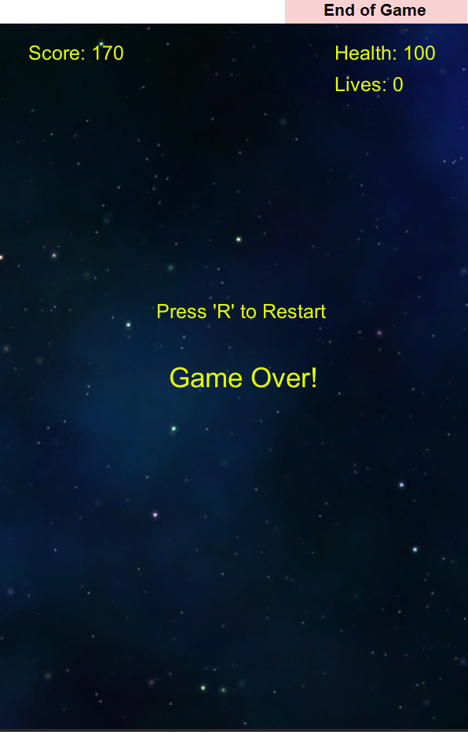

1. Game World

*There is gravity along the negative z-axis, i.e. from top to bottom of the screen.*

1. Levels

*There is currently one level of infinite asteroids.*

1. Vehicles

*A sleek spaceship with a moderately powerful laser cannon*

1. Enemies

*Asteroids – move toward the player with random velocity*

1. Weapons

*There is a main laser cannon on the spaceship.*

1. Script  
   *BGScroller – referenced from* [*Unity3d Tutorials*](https://unity3d.com/learn/tutorials/modules/beginner/live-training-archive/2d-scrolling-backgrounds)
2. Scoring  
   *Destroy the asteroids to get 10 points*
3. Bonuses

* *Listen to the cool soundtrack*

1. Sound Index

* *Explosion_asteroid.wav*
  + *From* [*http://www.trekcore.com*](http://www.trekcore.com/audio/explosions/smallexplosion3.mp3)
  + *Smallexplosion3*
* *Explosion_player.wav*
  + *From* [*http://www.trekcore.com*](http://www.trekcore.com/audio/explosions/smallexplosion3.mp3)
  + *Hullbreak3.wav*
* *Weapon_player.wav*
  + *From* [*http://www.sa-matra.net*](http://www.sa-matra.net/sounds/starwars/)
  + *ISD-Laser.wav – Star Wars Imperial Star Destroyer Turbolaser 4*
* *Music_background.wav*
  + *From* [*http://www.bensound.com*](http://www.bensound.com/royalty-free-music/track/epic)
  + *bensound-epic.wav*
* *Secondary Weapon ( not yet implemented )*
  + *From* [*http://www.stdimension.org*](http://www.stdimension.org/MediaLib/technology.htm)
* *Shipphaser2 – Star Trek*

1. Art / Multimedia Index
   * *Ship – From Free SciFi Fighter Publisher CGPitbull*

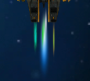

* + *Engine – From SimpleParticlePack Publisher Unity Technologies*
    - *SimpleFlame(Blue) renamed to prop_blue_thruster*
    - *SimpleFlame(Green) renamed to prop_green_thruster*
    - *Torch(Green) renamed to prop_green_trail*
  +  *-* Background – 7.jpg From [Webtreats ETC](http://webtreats.mysitemyway.com/tileable-classic-nebula-space-patterns/#etc-download-box) renamed to tile_nebula_blue
  + *Laser bolts from graphic artist - Andrew R. Alberts – free to use*
  + *Vaster Outer Space – free pack – Publisher: Prodigious Creations*
    - *Asteroids prefab, made copies of Material, Prefab, Mesh, Texture and edited references as needed to prop_asteroid_d*
    - *Destruction01 - Particle effect for asteroid explosion, renamed to explosion_asteroid*
    - *FlashRingFlame04 – Particle effect for player explosion, renamed to explosion_player*

1. Design Notes

*(Include additional design notes here)*

1. Future Features

*Add different sized asteroids*

*Add enemy ships*

*Add health counter*